PRESS RELEASE 3/2019

Smart keyseating machines shorten
production process

At the EMO 2019, German machine tools manufacturer Leistritz Produktionstechnik GmbH presents its keyseating machines that convince increased efficiency. Thanks to shorter
set-up times and increased process capability, previously unknown productivity is achieved with the new Polymat keyseating machines.

Pleystein/Germany (September 2019) – Reducing set-up times is becoming an increasingly important issue in order to reduce production costs. The aim is to make the set-up process as uncomplicated and process capable as possible. To offer a comfortable and reliable solution, Leistritz has developed a new system that reduces set-up times to a minimum.
Optimizing set-up times
"Now there are even more user-friendly set-up options available for the new machine generation of the Polymat keyseating machines , which at the same time ensure greater process capability and productivity," says Patrick Schuka, Head of Machine Tool Sales at Leistritz, proudly. "To keep set-up costs as low and simple as possible, our new tool clamping system now offers even greater safety and efficiency." Cutter bar and feed bar are securely clamped hydraulically at the push of a button. A positioning pin in the tool holder ensures the tool’s precise position. Readjustment is no longer necessary. At the same time, the cutter guide bar can be precisely positioned without readjustment by means of a zero point clamping system.
Determination of the workpiece zero point
The procedure for determining the workpiece zero point enables the precise recording of the cutter position after installation. The measured value is transferred to the control system. This then calculates the manufacturing parameters independently of the current tool position and ensures optimum machining precision. The result is: The effort for tool adjustment is significantly minimized, productivity and quality are increased.
Preventing tool damage
The two-piece keyseating tool, consisting of cutter bar and feed bar, was previously adjusted manually by the machine operator with a preload. Misadjustments could never be reliably ruled out and were possibly caused by the operator’s lack of experience. With the option of pneumatic clamping, the machine itself now takes over the setting of the optimum preload. Damage to the tool with high consequential costs is thus excluded.
Smart solutions on the rise
“With Leistritz' so-called condition monitoring, all systems can be intelligently networked,” explains Schuka. "In order to gain a quick overview of the systems’ status, we rely on intelligent sensors that provide information on the machine behavior.” This way, production keeps track of the efficiency of the systems – in real time!
The optional integration of a robot handling system is also an intelligent option. "With the possibility of unmanned operation, we are going consistently further along the path of automation," says the industry expert. "In addition, this opens additional personnel capacities to increase productivity elsewhere."
A further equipment option is the installation of a washing station. Not only is there no oil dripping, but the production area is less dirty. Above all, the result is a clean, finished workpiece. "We are permanently working on the further development of practical solutions. We offer our customers the turn-key-solution, both the machine and the automation", explains Patrick Schuka.

Leistritz Produktionstechnik GmbH at the EMO 2019:
Machine tools in hall 26/stand E95; tools in hall 4/stand B31

Image: ©Leistritz
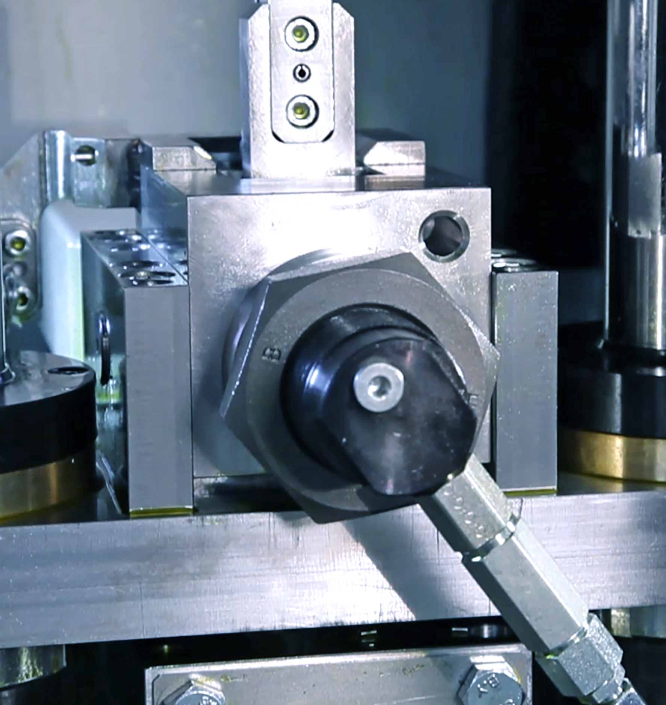
Picture: Hydraulic clamping system for the cutter bar

Leistritz Produktionstechnik GmbH
As part of the Leistritz Group, Leistritz Produktionstechnik GmbH, headquartered in Pleystein, offers solutions for the economical production of whirling machines, keyseating machines and carbide tools. Leistritz is a partner of the automotive and aerospace industries, the oil and gas industry, drive technology and insert and die making. Utilizing synergies from two different competencies – machine tools and tools – the company has developed a wealth of knowledge. The experience gained in both areas helps the company to continuously develop its technology and thus supply machines and tool solutions of the highest quality from a single source. The core competence lies in the development and production of customer-specific solutions and processes.

For more information:
Leistritz AG Leistritz Produktionstechnik GmbH
Public relations Head of Sales
Marija Perisic Patrick Schuka
Markgrafenstraße 36-39 Leistritzstr. 1 - 11
90459 Nuremberg/Germany 92714 Pleystein/Germany
T: +49 (0) 911 4306-120 T: +49 (0) 9654 89-403
E-Mail: mperisic@leistritz.com E-Mail: pschuka@leistritz.com

